NAME____________________________LAB MEETING DAY/TIME______________

Lab 6: Evolution

In this lab you will investigate evidence of evolution (Exercise 9), especially vestigial and homologous structures. Then, you will complete an activity NOT in your lab manual, examining the evolution of lizards by examining their characteristics and DNA evidence.

# **Exercise 9, Part A**

**Question 1: Record the correct order of the structures, from oldest to youngest.**

***OLDEST***

***C. Aktubites (Lower to Upper Pennsylvanian)***

***E. Paraschumardites (Upper Pennsylvanian)***

***A. Schumardites (Upper Pennsylvanian)***

***D. Properrenites (Lower Permian)***

***F. Metaperrinites (Mid Permian)***

***B. Perrinites (Mid Permian)***

***YOUNGEST***

# **Exercise 9, Part B**

**Question 1: Label as many homologous human bones on the diagram as you can identify.**

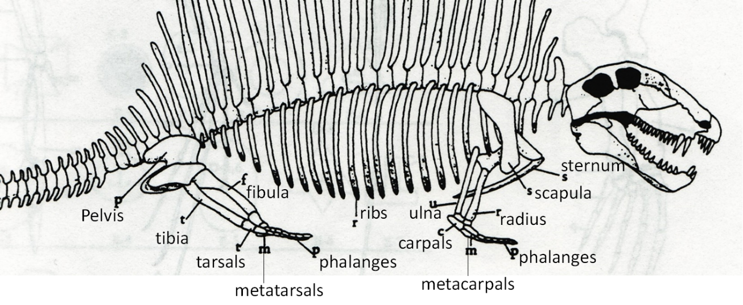

**Question 2: Follow the directions to color the homologous bones below. If you use different colors than indicated in the directions, include a legend below the figure.**

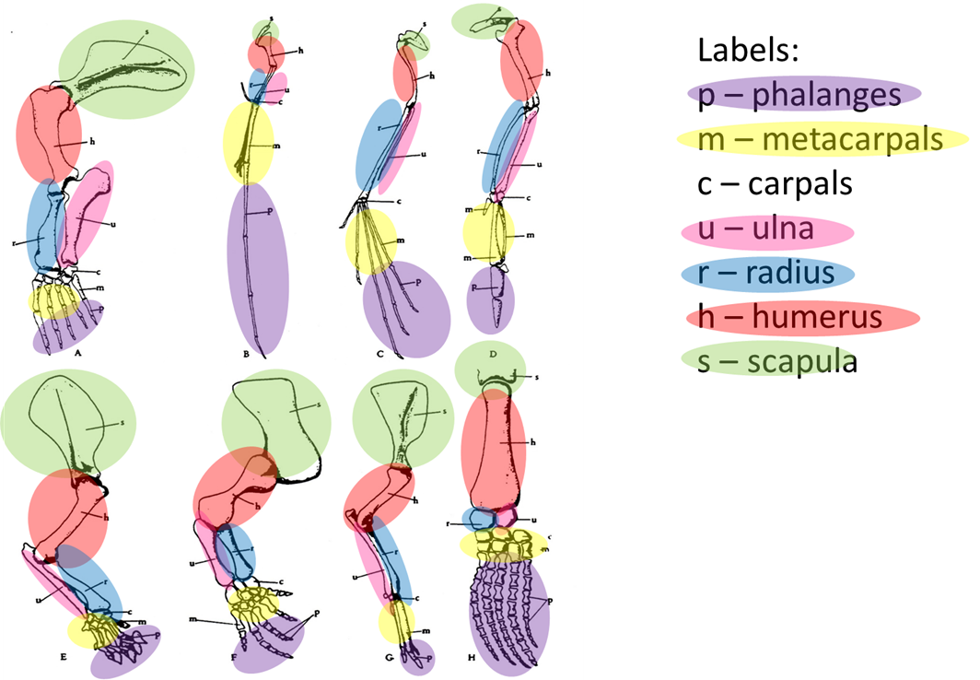

**Question 3: Summarize here:**

***Answers should discuss several different animals and their environment in terms of modifications. For example, in C (bat) the ulna, metacarpals, and phalanges are elongated to accommodate their wings.***

# Lab 6 Additional Exercise: Evolution of Anolis Lizards in the Greater Antilles

**You will work in groups of 3-4 on this lab – your instructor will hand out the instructions and materials once you have formed your groups. You will record answers here for grading, but need to refer to the exercise handouts to know what questions to answer.**

**Part I, Question 1**

***They are islands located south of Florida. They are made up of Cuba, Hispaniola, Puerto Rico, and Jamaica.***

***Anoles are tree-dwelling lizards (related to iguanas), found in tropical regions of the Americas. They have fingers and toes adapted for climbing. Males have throat fans in bright colors. More than 400 species of anoles exist. They eat insetcts.***

**Part I, Question 2**

***To use data, such as body shape and habitat to make hypotheses about how different species of Anolis lizards are related then to test these hypotheses using a phylogenetic tree.***

**Part II, Question 3**

***Identification number, name of lizard species found, island each lizard was found, its habitat, and body shape.***

**Part II, Question 4**

***slender body, very long tail***

***short body, slender legs and tail***

***large toe pads, can change color***

***large body, large toe pads***

***stocky body, long hind limbs***

***long fore limbs, flattened body***

**Part II, Question 5**

***Lizards with similar body shape live in similar habitats. For example, all slender body, very long tail lizards live in grasses and bushes.***

***• There are more lizards on the larger islands. For example, Jamaica only has four species of lizard, where as Cuba has all six species.***

***• Students may suggest patterns that relate to how the different body shapes may be adapted for the habitat that it lives in. For example, the lizards that live on twigs have short bodies and slender legs and tails. The smaller, lighter body may be advantageous when living on fragile vegetation.***

**Part II, Question 6 – SKIPPED ON ORIGINAL ANSWER SHEET**

***Yes, however not all islands have all of the species of lizards. For example, Jamaica has only four species and Puerto Rico has only five.***

**Part II, Question 7**

***Answers will vary. You will be looking for two additional hypotheses as to how the lizards may have speciated and evolved both on and between islands.***

**Part II, Question 8**

***Answers will vary. Students may suggest looking at fossils, using DNA, using other observations to determine how they are related to each other.***

**Part II, Question 9**

***Answers will vary. Students may suggest looking at fossils, using DNA, using other observations to determine how they are related to each other.***

**Part III, Question 10**

***Answers will vary but should describe the different patterns of the tree in terms of body shape, habitat, islands.***

**Part III, Question 11**

***Answers may vary, but in general students should recognize that lizards on the same island are more closely related to each other than lizards that have similar body shapes and live in the same type of habitat.***

**Part III, Question 12**

***Answers may vary, but should discuss whether this new data supports or refutes their hypothesis from question 8.***

**Part III, Question 13 – SKIPPED ON ORIGINAL ANSWER SHEET**

***Answers will vary. They may have swam, floated on natural rafts, the islands may have been connected at one point.***

**Part III, Question 14**

***Fossils could suggest which body type existed the earliest to most recent, suggesting which lizards may have inhabited the islands first. A comparison with fossils from lizards on the mainland may also help us understand how the group evolved and speciated.***

**Part III, Question 15**

***Answers will vary. They may have swam, floated on natural rafts, the islands may have been connected at one point.***